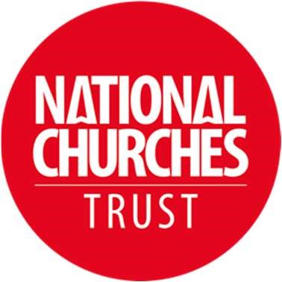
Grants Committee Members – volunteer positions
National Churches Trust

Commitment: Three meetings a year and approximately five decision rounds via email (requiring time to read papers in advance to meetings, and to respond to emails)
Yours for good.

Location: In person (usually London) and hybrid

Role description

Do you love church buildings and want them to remain a sustainable part of our heritage and playing a vital role in community life? Perhaps you have experience helping keep historic buildings open and well maintained, or have championed their social and community value, or have experience leading church building or engagement projects? Then please consider joining our grants committee.
We are looking for at least two new members for our independent grants committee. The committee has the key responsibility of allocating the Charity’s annual grants budget of around £1.5million. We strive to ensure our committee has experience which spans the UK and across denominations, and we seek members with a range of interests and insights. Potential candidates may be incumbents, heritage professionals, tourism experts, fundraisers or church volunteers to name a few. We are especially keen to recruit a new member based in Wales/Cymru.
About the National Churches Trust
Churches, chapels and meeting houses are impressive, exciting and surprising places, and we want to see them kept open and well used. Whether people seek quiet reflection, access to critical community services, a place to worship, or a space to explore, we believe these buildings should be cherished, supported, and available to all. Working together with churches across all four nations and all denominations, we help to maintain these wonderful buildings and keep them thriving today, and tomorrow. Our current strategy ‘For Churches’ can be found here.

More about the role
The Committee meets three times a year with at least one meeting in person; others are hybrid. At each meeting decisions are made on our Medium and Large grant programmes, as well as funds we administer on behalf of other Trusts and Foundations including the Wolfson Foundation and the National Lottery Heritage Fund. Small grant recommendations are currently circulated via email five times a year. Further information on our programmes can be found here.

National Churches Trust funds can be allocated to listed and unlisted buildings for maintenance, repair, facilities and project development work. We look to the Grants Committee to consider the applications in front of them in the light of their experience, to help us direct our limited budget to projects which demonstrate the greatest case for the Charity’s investment and where our funds can have greatest impact and benefit, in line with our strategy.

If you have any questions about this opportunity please contact Catherine Townsend, Director of Church Engagement, on 020 7227 1933, or by email at: catherine.townsend@nationalchurchestrust.org

Please note these positions are voluntary and so are unremunerated, although out of pocket expenses will be reimbursed.

The National Churches Trust is committed to encouraging equality, diversity and inclusion amongst its trustees, staff, volunteers and beneficiaries.

To express your interest, please send a covering letter (max 2 sides) detailing your interest in the role and how you meet the requirements, preferably together with a copy of your CV, to catherine.townsend@nationalchurchestrust.org.

From those who express an interest, a shortlist will be selected and invited to an online meeting with the Chair of the Grants Committee and the Director of Church Engagement on the 31 January or 1 February. The successful candidates will be expected to attend in person our first Grants Committee meeting of 2024, being held in London on Thursday 14 March.

Closing date: 9am, Monday 15 January

