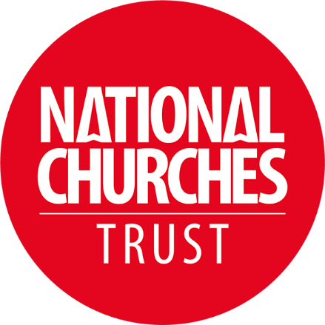
Title: How the National Churches Trust is supporting churches, like [insert church name], to remain open and in use

The National Churches Trust is delighted to support the [INSERT NAME OF PLACE OF WORSHIP] with a grant towards [INSERT WORK BEING FUNDED].

Churches, chapels and meeting houses are impressive, exciting and beautiful places. Working together with churches across all four nations, the National Churches Trust helps to keep these wonderful historic buildings in good repair and with modern community facilities. Our aim is to ensure these buildings can stay thriving today and tomorrow.

Since 1953, thanks to the generosity of our Friends and supporters, the National Churches Trust have provided over 12,000 grants and loans and ensured that thousands of churches, chapels and meeting houses throughout the UK have remained open and in use, supporting local people and at the centre of thousands of communities.

In 2022, through our grants we were able to remove 18 Churches and chapels from Historic England's’ Heritage at Risk Register.

How you can help us

You can help us to support even more churches by becoming a Friend of the National Churches Trust. Your support will make a vital difference and help even more historic churches remain open and in use for generations to come.

The benefits of your membership include deciding each summer – along with other Friends – which church in the UK to award an additional grant of £10,000 to in order to help with urgent repairs and maintenance. You’ll also be the first to know about important news and events, receive a copy of our Annual Review, our bi-annual Friends Newsletter, monthly email newsletter and invitations to exciting events, including church tours.

New Friends also receive a free copy of Treasures of English Churches by Dr Matthew Byrne, a beautiful and inspiring book on the wonderful treasures that churches contain.
The future of the nation’s churches is in our hands. We need to ensure that they are valued and saved for the future, before it is too late.

Join us today at: www.nationalchurchestrust.org/friends or telephone us on 020 7222 0605 or email info@nationalchurchestrust.org

Speaking up and speaking out

Churches are the beating hearts of our communities. The National Churches Trust will continue to speak up to champion churches, like [INSERT CHURCH NAME], as well as to push for the sustainable support that churches across all four nations urgently need. Through our grants, we will continue to support churches to help them to remain in good condition and open for all.

