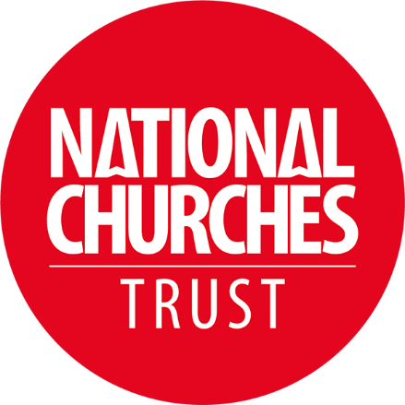
Insert a succinct headline

A good headline is the first thing a journalist will see, so write one that encapsulates your story as well as hooks their attention and makes them read on.

National Churches Trust awards a £X,XXX grant towards developing a major project at [Insert name of] Church.

Insert the DATE
Include the date that you’re sending the press release out on.

Date: Day, Month, Year

Insert embargo or if the information can be published right away
Some press releases have an embargo, which means the content of the press release must not be published before a certain date and time. This can be helpful if you are wanting the content to be published after an event or to coincide with something else that is happening.

For immediate release
Embargo: Time, Day, Month, Year

Introduction
The first paragraph should be a summary of all the information the journalist needs to know. This should include the Who, What, Where, Why and How. Please note that we would like you to mention our grant here, and we are happy for you to list other funders.

The future of [Name your church] is one step further to being secured after a £X,XXX grant from the National Churches Trust to fund an essential repairs to the church tower and to create an accessible kitchen and toilet, so we can better serve the local community.

Main information
The next two or three paragraphs should be descriptive of the project and grant. It is best to avoid the use of technical, academic or architectural language and to instead emphasise the community benefits. A certain amount of background is necessary to give context to the grant. Interesting facts and statistics about your church give good material for journalists – eg tallest tower, how many people use your church building for services and other activities that your church runs for the community etc. And of course, include a description of what will be done with the grant money.

The church has been at the heart of the community for more than 900 years and has served as inspiration for T.S. Eliot’s The Stone. Today, it is not only used for services, but also as a crèche, a space for community group meetings and as a concert venue. The work, which can now begin in January, will allow the church to restore the crumbling tower and to add in crucial facilities, such as toilets and a kitchen, to support the wider community use of the church while protecting the sensitive historic fabric of the church.

Conclusion
The final paragraph should contain quotes from someone from your place of worship or a well-known supporter of the project that journalists can print in full. This should be short, direct and should sum up the information in the rest of the release.

NAME, JOB TITLE from NAME OF YOUR CHURCH said “The work proposed at [Church Name] will help develop a long-term vision for the church that will ensure the church can serve the community seven days a week. This is the start of an exciting journey to secure the future of this historic church, to equip it for the 21st century and to ensure the church really can be open for all.”

Ends

Notes to the editor
The first thing to include in this section is a named contact, their phone number, email address and website details about your place of worship and the website of the National Churches Trust. It is important that your named contact is available after you send the press release as the journalist may call you for further details, images, to arrange an interview or to come and visit your church.

For further details please contact: Firstname Lastname on [insert mobile number] or [insert email address.

[insert church website address]
www.nationalchurchestrust.org

The next thing to include in this section is more information, should you have it. This could be examples of other projects that you’ve completed at your church recently or links to other community activities that you run at your church.

We would appreciate you please mentioning the National Churches Trust here:
About the National Churches Trust: National Churches Trust works in partnership with churches across the UK to keep them open and in use. Whether seeking quiet reflection, access to critical community services, a warm welcome or a place to worship, we believe churches should be loved and supported, and available to all. Working together with churches across all four nations, we help to maintain these wonderful historic buildings and keep them thriving today, and tomorrow.
For more information visit www.nationalchurchestrust.org

Photographs
Photos are extremely helpful for journalists and will make it more likely that a publication will publish your story, as they won’t have to spend time searching for images.

The best way to send images on a press release is to add a link to them that journalists will be able to access. You can do this by using photo storage sites such as Dropbox, Google Drive or Flickr. This is because if you attach an image directly to the email, it will usually be sent straight to spam and it is unlikely a journalist will receive it.

Photo checklist

- Make sure the photos are of good quality
- Ensure that you only share photos that you have permission to use and make clear if the images should be credited a certain way. Using photos without proper consent could end up costing thousands of pounds in copyright fees.
- Make sure you include a good selection of photos eg featuring the outside of your church, photos of any damage that will be repaired, sketches or architectural drawings/illustrations of the work to be carried out, photos of the project team who are overseeing the work.

