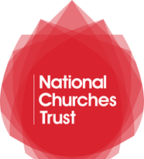

ORDER FORM

English Parish Churches and Chapels: Architecture, Art and People
by Dr Matthew Byrne

Hardback book by Matthew Byrne
Order price: £15.00

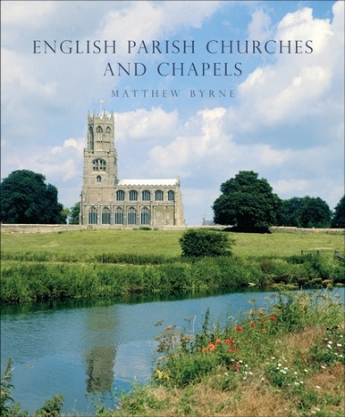
English Parish Churches and Chapels: Architecture, Art and People is a beautiful and inspiring book of photographic portraits produced exclusively for the National Churches Trust by Dr Matthew Byrne, Fellow of the Royal Photographic Society.

The book celebrates 26 English churches and chapels- many of which have received funding from the National Churches Trust. With a message of support from our Patron Her Majesty The Queen, and a foreword by our Vice President Michael Palin, this book is a perfect companion for those summer walks and days spent exploring churches.
Yes, I would like to order English Parish Churches and Chapels
by Matthew Byrne

I would like …………. copies at £15.00 each
I enclose cash/a cheque/a postal order for £………………… made payable to the National Churches Trust

Name: …………………………………………………………………………………………………………………………………..
Address: …………………………………………………………………………………………………………………………………
Telephone: ……………………………………………………………………………………………………………………………..
We will only phone you if we have a query about this specific order and will not use this number for any other purposes.
The National Churches Trust and your details (please read carefully)
- We do not sell or swap your details with any other organisation
- We keep your details private and store them securely
- We would like to contact you by post in the future with updates about our work. If you would prefer not to receive communications from us by post, please tick the box.

